**Use Case 1: Creating a Room**

Primary Actor:

* User

Stakeholders and Interests:

* User wanting to create a room

Preconditions:

* User is logged in

Success Guarantee:

* Room is created with configuration specified by the user
* User has host privileges in the room

Main Success Scenario:

1. User clicks create room button
2. User prompted with configuration details
3. User selects desired configuration settings and accepts
4. System creates new room with user selected configurations
5. User is greeted with the room screen

Extensions:

3. User fails to give proper specifications

1. System notifies user about error
2. User fixes error

Special Requirements:

1. Room should be created within 2,000 ms

Technology and Data Variation:

* None

List Frequency of Occurrence:

* Whenever a user wants to create a room

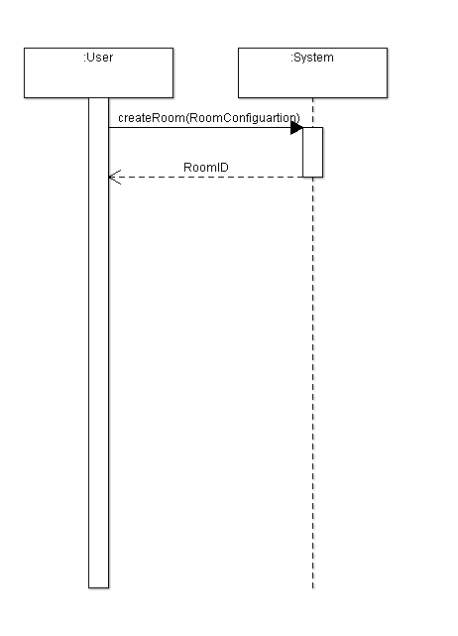

**Use Case 2: Joining a Room**

Primary Actor:

* User

Stakeholders and Interests:

* User wanting to join a room

Preconditions:

* User is logged in
* At least one room exists

Success Guarantee:

* User joins the chosen room successfully
* User is granted user permissions only

Main Success Scenario:

1. User searches for intended room
2. User clicks intended room
3. User clicks on “Join Room”
4. System adds new user to room
5. User is greeted with the room screen

Extensions:

2. Password is required

1. User enters password

2. System validates password

1. User is notified if password incorrect
2. User is provided with link

1. User clicks link

2. User clicks “Join Room”

1. User prompted with password input
2. User enters password
3. System validates password

3. User successfully joins room

4. User is on room’s blacklist

1. User is notified that they can not join the room

Special Requirements:

1. User should be added within 2,000 ms

Technology and Data Variation:

* None

List Frequency of Occurrence:

* Whenever a user wants to join a room

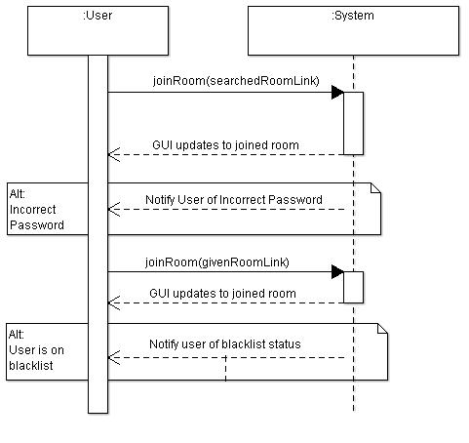

**Use Case 3: Sharing a Room**

Primary Actor:

* User

Stakeholders and Interests:

* User wanting to share a room
* Other user that is receiving the shared room link

Preconditions:

* User is logged in
* User is part of a room

Success Guarantee:

* Link is generated
* Link is sent out by user through outside messenger

Main Success Scenario:

1. User clicks on their room
2. User clicks “Share Room” button
3. System generates a link to the room
4. User is prompted with the link
5. User sends out link using an outside messenger

Extensions: Only user errors

Special Requirements:

1. Link should be generated within 2,000 ms

Technology and Data Variation:

* Link is able to be copied and pasted

List Frequency of Occurrence:

* Whenever a user wants to share a room

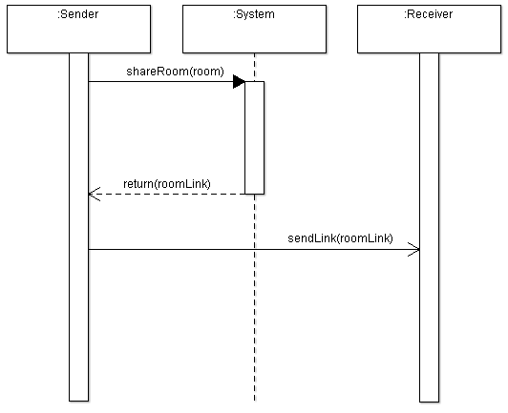

**Use Case 4: Kicking someone from a room**

Primary Actor:

* User with Host privileges in room

Stakeholders and Interests:

* Host wanting a member to be kicked

Preconditions:

* User is a host
* User is part of a room

Success Guarantee:

* User is successfully kicked by host

Main Success Scenario:

1. Host clicks on desired user
2. Prompted with user account
3. Clicks “Kick User”
4. Prompted with a “Ban” option
5. Host clicks the button
6. System removes user from room
7. System registers user as a ban user
8. User is successfully kicked from the room

Extensions:

6. Said user has already left the room

a. Host prompted with error message, user not in room

Special Requirements:

1. Request should be processed within 2,000 ms

Technology and Data Variation:

* None

List Frequency of Occurrence:

* Whenever a host wants to kick a user from a room

